

**A project Report on**

**GLOBALSQA USING AUTOMATION TOOL SELENIUM WEBDRIVER WITH JAVA.**

**By**

**Rajashree Chitale**

**Batch-EON (2021-5532)**

**Under the Guidance of,**

**Amruta Deore**

**(Technical Trainer)**

**EduBridge India Pvt. Ltd.**

**Introduction:**

This Project aims to do overall testing like functional testing, GUI testing on Demo tour website to check quality of application using selenium web driver. It helps to improve quality of website and saves time for manually doing this testing.

This Website for cheat sheets, Mind maps, free Ebooks. In this project our main focus is to test the tester’s hub module. In this tester’s hub, the different web element are available for testing purpose. In this website we also test the course enrolment details.

**Software Requirements:**

Operating System: Windows 10

Browser: Latest version of Google Chrome

Platform: Eclipse IDE

Automation Tool and Language: Selenium WebDriver, Java

Files: JDK, Selenium Jar files, Common IO file

1. **GLOBALSQA MODULE**

**TC01:** Launch the browser and Globalsqa website

**Selenium WebDriver Test Script:**

WebDriver d = **new** ChromeDriver();

d.manage().window().maximize();

driver.manage().deleteAllCookies();

driver.manage().window().maximize();

driver.manage().timeouts().implicitlyWait(30, TimeUnit.***SECONDS***);

driver.manage().timeouts().pageLoadTimeout(40, TimeUnit.***SECONDS***);

driver.get("https://www.globalsqa.com/");

**

**TC02:** To verify the functionality of Globalsqa

**Selenium WebDriver Test Script:**

d.findElement(By.xpath("//body/cclink[1]/main[1]/div[2]/section[1]/div[2]/a[1]/div[1]")).click();

**TC03:** To verify Title and Display Passed On Console.

**Selenium WebDriver Test Script:**

String expectedTitle ="CheatSheets, Mindmaps, Free Ebooks- GlobalSQA";

String actualTitle ="";

actualTitle = driver.getTitle();

**if**(actualTitle.contentEquals(expectedTitle))

{

System.***out***.println("Test Passed");

}

**else**

{

System.***out***.println("Test Failed");

}

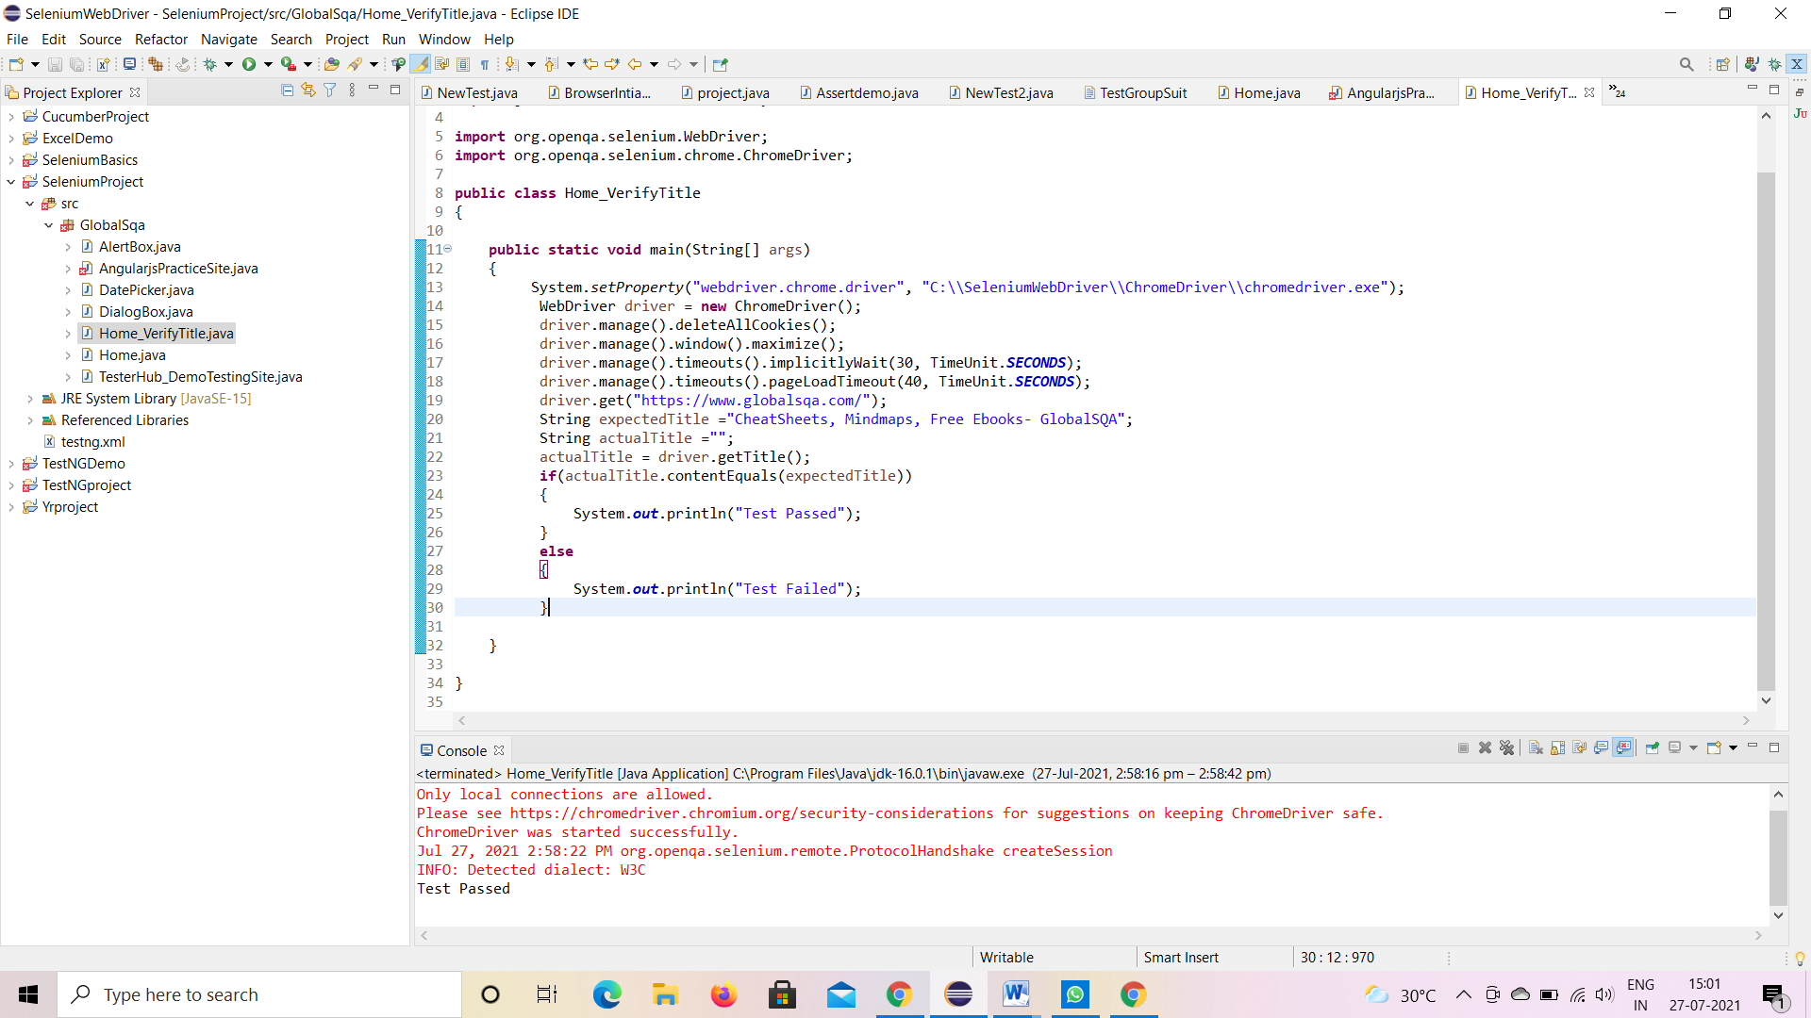

**TC04:** To verify and display the Title of the current page.

**Selenium WebDriver Test Script:**

d.getTitle();

System.***out***.println("Title of page is:" + d.getTitle());

**TC05:** To verify the Footer Of Home Page.

**Selenium WebDriver Test Script:**

driver.findElement(By.*className*("header_soc_facebook")).click();

driver.findElement(By.*className*("header_soc_google")).click();

driver. findElement(By.*className*("header_soc_linkedin")).click();

driver. findElement(By.*className*("header_soc_twitter")).click();

driver. findElement(By.*className*("header_soc_pinterest")).click();

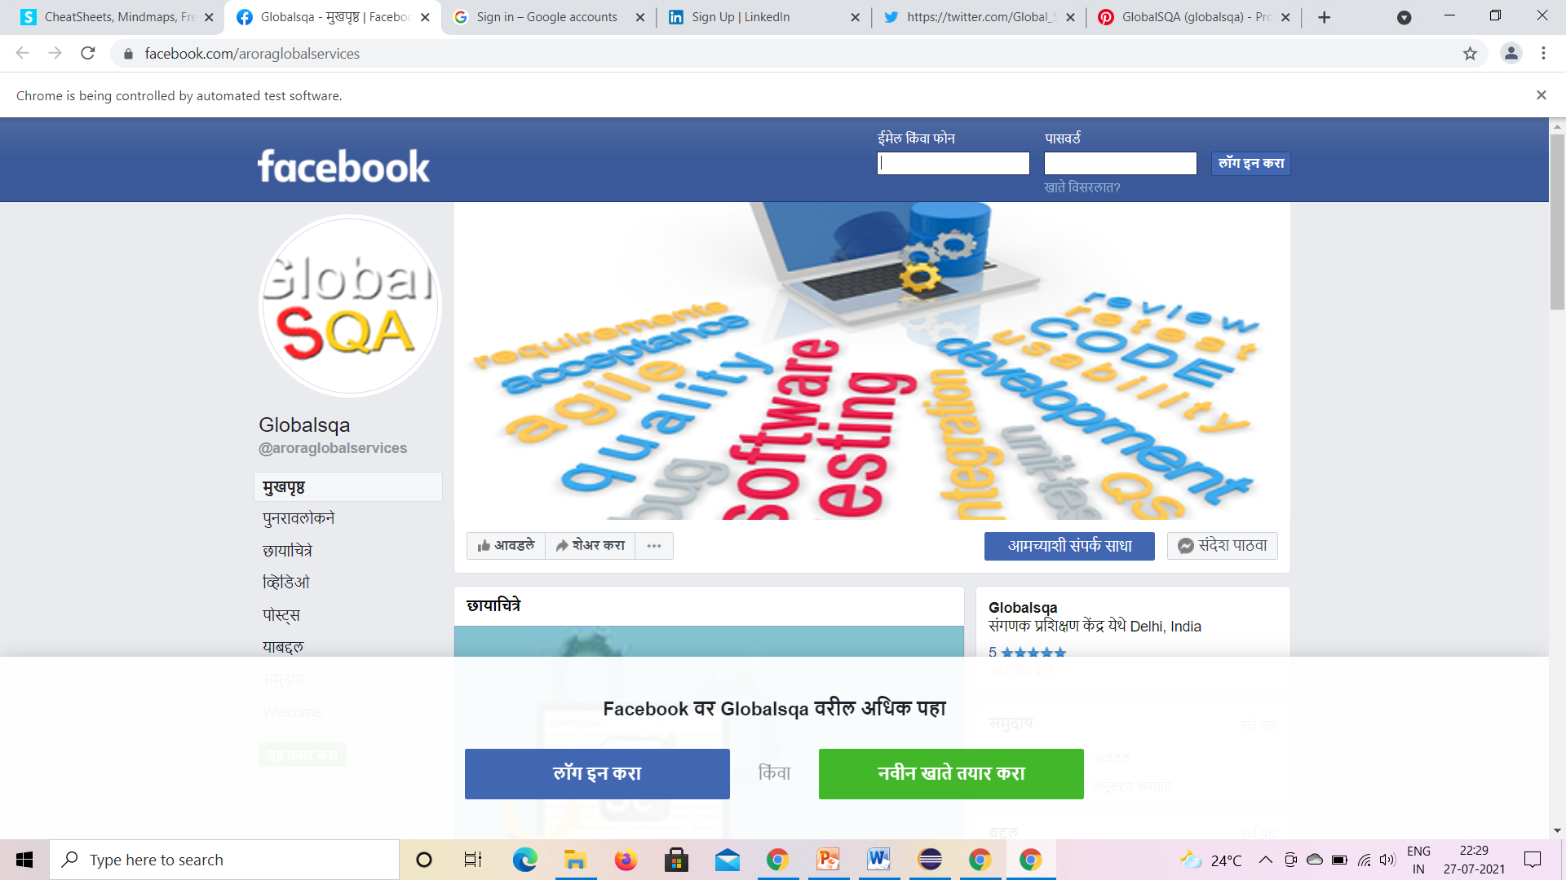

**TC06:** To verify the functionality of Search Button.

**Selenium WebDriver Test Script:**

driver.findElement(By.*id*("s")).sendKeys("CHEATSHEETS");

driver.findElement(By.*className*("button_search")).click();

**try**

{

Thread.*sleep*(2000);

}

**catch** (InterruptedException e)

{

e.printStackTrace();

}

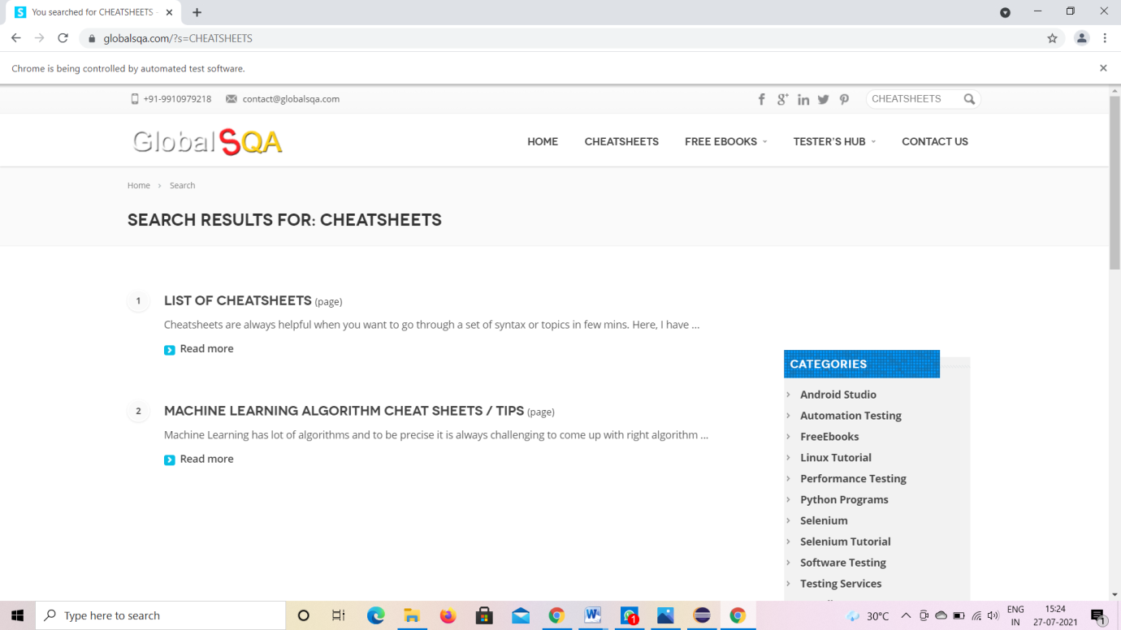

**TC07:** To verify the functionality of Scroll Bar And Select Training And Tool Options.

**Selenium WebDriver Test Script:**

((JavascriptExecutor)driver).executeScript("scroll(0,400)");

driver.findElement(By.*id*("Tools")).click();

**try**

{

Thread.*sleep*(2000);

}

**catch** (InterruptedException e)

{

e.printStackTrace();

}

driver.findElement(By.*id*("Trainings")).click();

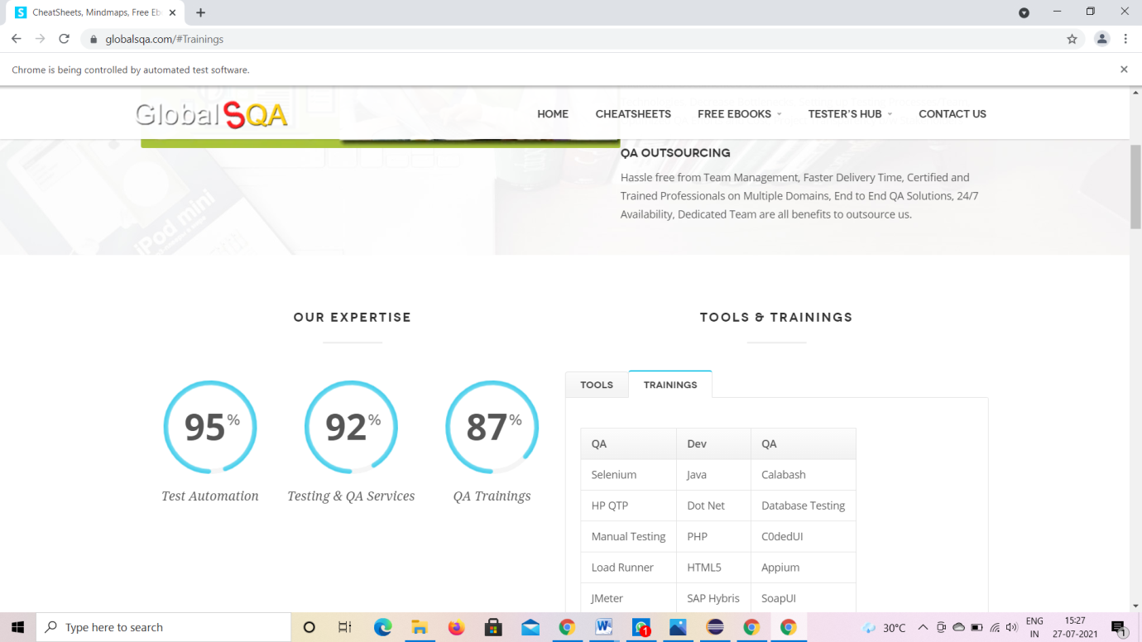

**TC08:** To verify the functionality Of Scroll Bar And Select

Training.

**Selenium WebDriver Test Script:**

((JavascriptExecutor)driver).executeScript("scroll(0,1300)");

driver.findElement(By.*className*("jcarousel-next jcarousel-next-horizontal")).click();

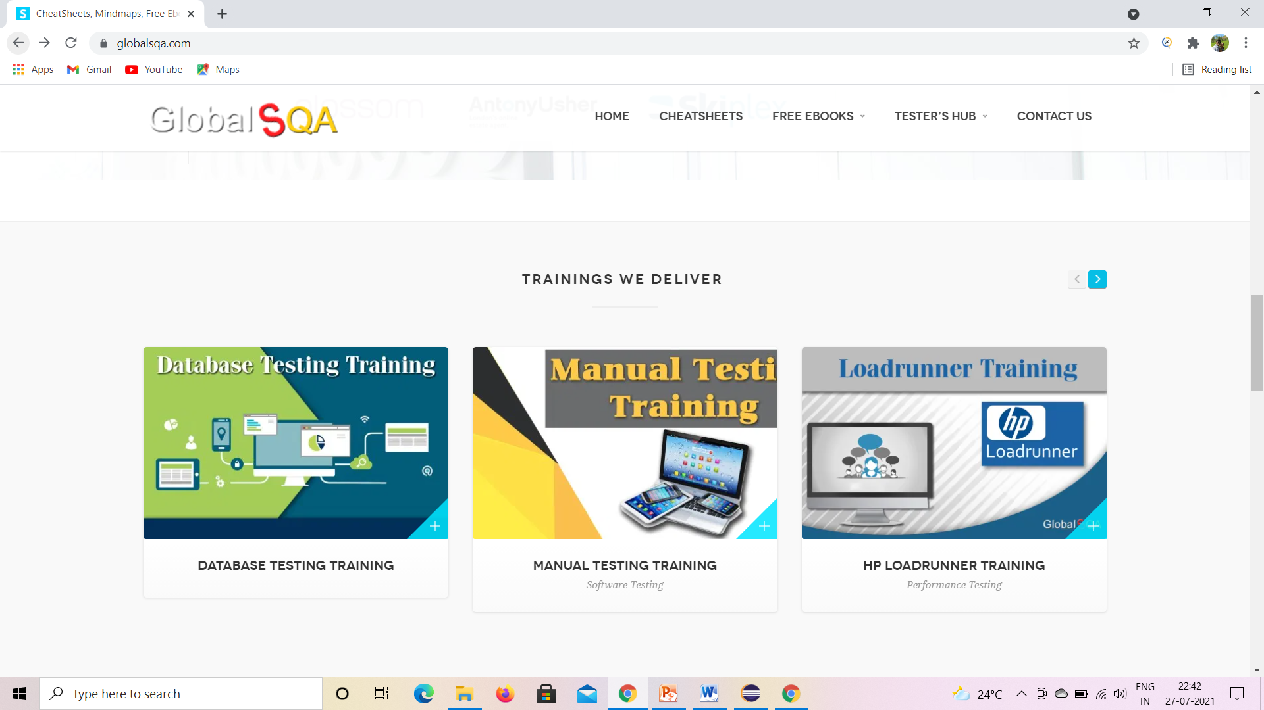

**TC09:** To verify the Mouse Over Functionality And Select Demo Testing Site.

**Selenium WebDriver Test Script:**

WebElement TesterHub = driver.findElement(By.*xpath*("//*[@id=\"menu-item-2822\"]/a")); //mouse over on testerhub

Actions builder = **new** Actions(driver);

builder.moveToElement(TesterHub).build().perform();

WebElement DemoTesting = driver.findElement(By.*xpath*("/html/body/div/header/div[2]/div/div/div[3]/div/ul/li[4]/div/ul/li[1]/a/span")); //mouse over on demo testing site

Actions builder1 = **new** Actions(driver);

builder1.moveToElement(DemoTesting).build().perform();

driver.findElement(By.*xpath*("/html/body/div/header/div[2]/div/div/div[3]/div/ul/li[4]/div/ul/li[1]/div/ul/li[1]/a/span")).click();

driver.findElement(By.*id*("Forms Based")).click();

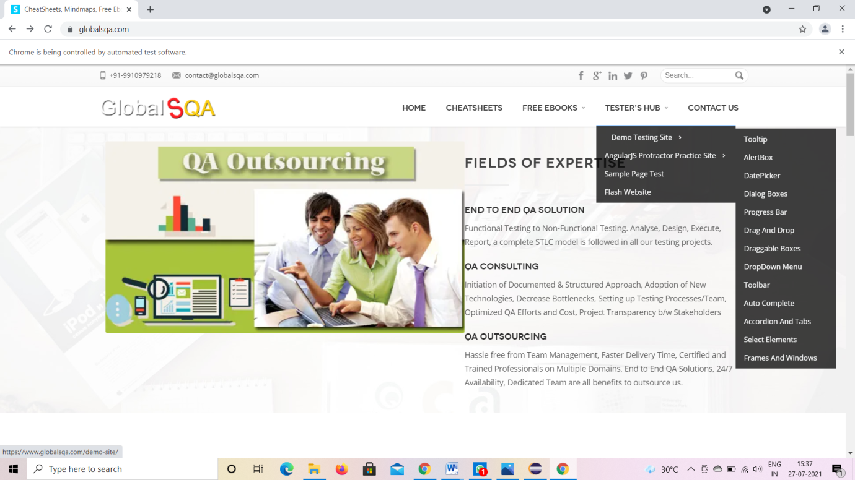

**TC10:** To verify the functionality of Tooltip

**Selenium WebDriver Test Script:**

WebElement DemoTesting = driver.findElement(By.*xpath*("/html/body/div/header/div[2]/div/div/div[3]/div/ul/li[4]/div/ul/li[1]/a/span"));

Actions builder1 = **new** Actions(driver);

builder1.moveToElement(DemoTesting).build().perform();

driver.findElement(By.*xpath*("/html/body/div/header/div[2]/div/div/div[3]/div/ul/li[4]/div/ul/li[1]/div/ul/li[1]/a/span")).click(); //click on tooltip

driver.findElement(By.*id*("Forms Based")).click();

**TC11:** To verify Dialog Box Functionality.

.

**Selenium WebDriver Test Script:**

WebElement DemoTesting = driver.findElement(By.*xpath*("/html/body/div/header/div[2]/div/div/div[3]/div/ul/li[4]/div/ul/li[1]/a/span")); //mouse over on demo testing site

Actions builder1 = **new** Actions(driver);

builder1.moveToElement(DemoTesting).build().perform();

driver.findElement(By.*xpath*("/html/body/div/header/div[2]/div/div/div[3]/div/ul/li[4]/div/ul/li[1]/div/ul/li[4]/a/span")).click();

**TC12:** To verify the functionality of AlertBox.

**Selenium WebDriver Test Script:**

WebElementDemoTesting= driver.findElement(By.*xpath*("/html/body/div/header/div[2]/div/div/div[3]/div/ul/li[4]/div/ul/li[1]/a/span")); //mouse over on demo testing site

Actions builder1 = **new** Actions(driver);

builder1.moveToElement(DemoTesting).build().perform();

driver.findElement(By.*xpath*("/html/body/div/header/div[2]/div/div/div[3]/div/ul/li[4]/div/ul/li[1]/div/ul/li[2]/a/span")).click(); //click on alertbox

**TC13:** To verify the functionality of DatePicker.

**Selenium WebDriver Test Script:**

WebElementDemoTesting= driver.findElement(By.*xpath*("/html/body/div/header/div[2]/div/div/div[3]/div/ul/li[4]/div/ul/li[1]/a/span")); //mouse over on demo testing site

Actions builder1 = **new** Actions(driver);

builder1.moveToElement(DemoTesting).build().perform();

driver.findElement(By.*xpath*("/html/body/div/header/div[2]/div/div/div[3]/div/ul/li[4]/div/ul/li[1]/div/ul/li[3]/a/span")).click(); //click on alertbox

driver.findElement(By.*id*("Icon Trigger")).click();

**TC14:** To verify the functionality of Angularjs Protect Practice Site.

**Selenium WebDriver Test Script:**

WebElementDemoTesting= driver.findElement(By.*xpath*("/html/body/div/header/div[2]/div/div/div[3]/div/ul/li[4]/div/ul/li[1]/a/span")); //mouse over angularjs

Actions builder1 = **new** Actions(driver);

builder1.moveToElement(DemoTesting).build().perform();

WebElementAngularjs= driver.findElement(By.*xpath*("//*[@id=\"menu-item-2822\"]/a"));

Actions Ajs= **new** Actions(driver);

builder.moveToElement(Angularjs).build().perform();

**TC16:** To verify the Functionality Of Filter.

**Selenium WebDriver Test Script:**

driver.findElement(By.*xpath*("/html/body/div/header/div[2]/div/div/div[3]/div/ul/li[4]/div/ul/li[2]/div/ul/li[1]/a/span")).click();

**TC17:** To verify The Functionality Of Scrollable.

**Selenium WebDriver Test Script:**

WebElementTesterHub= driver.findElement(By.*xpath*("//*[@id=\"menu-item-2822\"]/a")); //mouse over on testerhub

Actions builder = **new** Actions(driver);

builder.moveToElement(TesterHub).build().perform();

WebElementAngularjs= driver.findElement(By.*xpath*("/html/body/div/header/div[2]/div/div/div[3]/div/ul/li[4]/div/ul/li[2]/a/span")); //mouse over on Angularjs

Actions builder1 = **new** Actions(driver);

builder.moveToElement(Angularjs).build().perform();

driver.findElement(By.*xpath*("/html/body/div/header/div[2]/div/div/div[3]/div/ul/li[4]/div/ul/li[2]/div/ul/li[2]/a/span")).click();

**TC18:** To verify and Functionality Of Multiform.

**Selenium WebDriver Test Script:**

WebElementTesterHub= driver.findElement(By.*xpath*("//*[@id=\"menu-item-2822\"]/a")); //mouse over on testerhub

Actions builder = **new** Actions(driver);

builder.moveToElement(TesterHub).build().perform();

WebElementAngularjs= driver.findElement(By.*xpath*("/html/body/div/header/div[2]/div/div/div[3]/div/ul/li[4]/div/ul/li[2]/a/span")); //mouse over on Angularjs

Actions builder1 = **new** Actions(driver);

builder.moveToElement(Angularjs).build().perform();

driver.findElement(By.*xpath*("/html/body/div/header/div[2]/div/div/div[3]/div/ul/li[4]/div/ul/li[2]/div/ul/li[3]/a/span")).click();

driver.findElement(By.*name*("name")).sendKeys("Rajashree");

driver.findElement(By.*name*("email")).sendKeys("chitalerajashree@gmail.com");

**TC19:** To verify the navigation to go back to previous page.

**Selenium WebDriver Test Script:**

d.navigate().back();

**TC20:** To verify that browser is able to close.

**Selenium WebDriver Test Script:**

d.close();